Future of Flood Risk Data



This page is intentionally blank.

Contents
Section 1 —Basin Overview 1
1.1 Basin Description 1
1.2 Data Preparation Overview 1
1.3 Future of Flood Risk Data Project Workflow 1
Section 2 —Standards 3
2.1 Projection 3
2.2 Vertical Datum 3
2.3 Time Zone 3
2.4 Access to All Prepared Data 3
2.5 Data Manifest 3
2.6 Storage Location and Directory Structure 4
2.7 Project Work Plan—Basin Execution 4
Section 3 —Scoping 5
3.1 Watershed Study Extent 5
3.2 External Boundary Conditions 5
3.3 Model Order Design 5
3.4 Enumeration of Cloud Simulations 5
3.5 Naming Table 5
3.6 Dam Scoping Table 5
3.7 Levee Model Scoping Table 5
3.8 Levee Draft Breach Locations 5
3.9 Mesh Development Guidance 5
3.9.1 Mesh Development Categories 5
3.10 Delineation of Hydrologic Modeling Basin Elements 6
3.11 Delineation of Hydraulic Modeling Units 6
3.12 Calibration Events 6
3.13 Calibration Metric Hierarchy 6
3.14 Structure Survey Scope 6
3.15 Stakeholder Engagment 6
Section 4 —Prepared Data 7
4.1 Geospatial Data 7
4.1.1 Terrain 7
4.1.2 Elevation Derived Hydrography 7
4.1.3 Land Cover 7
4.1.4 Soils 7
4.1.5 National Levee Database 7
4.1.6 National Inventory of Dams 7
4.1.7 National Structure Inventory 7
4.1.8 Bathymetry Data 7
4.1.9 Stream Gage Network 7
4.1.10 U.S. Census Bureau Topologically Integrated Geographic Encoding and
Referencing Data 7
4.1.11 National Bridge Inventory 8
4.2 Observed Data 8
4.2.1 Observed Stream Gage Hydrographs 8
4.2.2 Stream Gage Measurement Data 8
4.2.3 Stream Gage Annual Peak Data 8
4.2.4 Stream Gage Stage Discharge Relationships (Ratings) 8
4.2.5 High Water Mark Data 8
4.2.6 Flood Imagery 8
4.2.7 Period of Record Gridded Data 8
4.2.8 Observed Storm Event Gridded Data 8
4.2.9 Observed Precipitation 9
4.2.10 Observed Snow Water Equivalent 9
4.2.11 Observed Temperature Data 9
4.2.12 Analysis Products 9
4.3 Meteorology 9
4.3.1 Transposition Region 9
4.3.2 Storm Catalog 9
4.3.3 Normalization Grid 9
4.3.4 Fishnets 9
4.4 Hydrologic Modeling 9
4.5 Reference Data 9
4.5.1 Dam Structure and Operation Information 9
4.5.2 Vertical Datum Conversions 10
4.6 Federal Emergency Management Agency Datasets 10
4.6.1 Flood Insurance Study Effective Reports 10
4.6.2 Flood Insurance Study Effective Models 10
4.6.3 Flood Insurance Study Effective Layers 10
4.6.4 Federal Emergency Management Agency Base Level Engineering Reports 10
4.6.5 Federal Emergency Management Agency Base Level Engineering Models 10
4.6.6 Federal Emergency Management Agency Base Level Engineering Data 10
4.7 National Levee Database—Data Refinement 10
4.8 National Inventory of Dams—Data Refinement 10
4.9 Existing Risk Assessments 10
Section 5 —Quality Control Reviews 11
5.1 Technical Reviews 11
5.2 Quality Control 11
List of Acronyms and Abbreviations 13

List of Figures
Figure 1.1. Five Phases of Future of Flood Risk Data Project Delivery 2

List of Tables
Table 1.1. Key Team Members for Scoping and Data Preparation Effort 1
Table 2.1. Geospatial Projection Details 3

Content Approval
The products described and contained in this report have undergone quality control (QC) reviews according to procedures described in the standard operating procedure (SOP).

Project Team Lead
Name
Title
Agency

Future of Flood Risk Data Program Lead
Name
Title
Agency

This page is intentionally blank.

Approval to Proceed
The products described and contained in this report have undergone quality assurance (QA) reviews by the Future of Flood Risk Data (FFRD) Technical Oversight Group (TOG). All technical requirements described in the SOP are met and the products are adequate for use to assess flood risk for the study basin.
Signature constitutes approval to proceed to the calibration phase.

Technical Oversight Group Representative
Name
Title
Agency

—Basin Overview

Basin Description
General description of the physical characteristics of the basin.

Data Preparation Overview
Include discussion of team activities during the scoping and data preparation effort, stakeholder engagement, and project start date.
Table 1.1. Key Team Members for Scoping and Data Preparation Effort
Role | Team Member

Future of Flood Risk Data Project Workflow
This report describes all effort by the team to complete the Scoping and Data Preparation Phase of the FFRD project for [basin name] basin. In the context of delivery of the entire FFRD project delivery, this is the first of five phases (Figure 1.1).
Figure 1.1. Five Phases of Future of Flood Risk Data Project Delivery
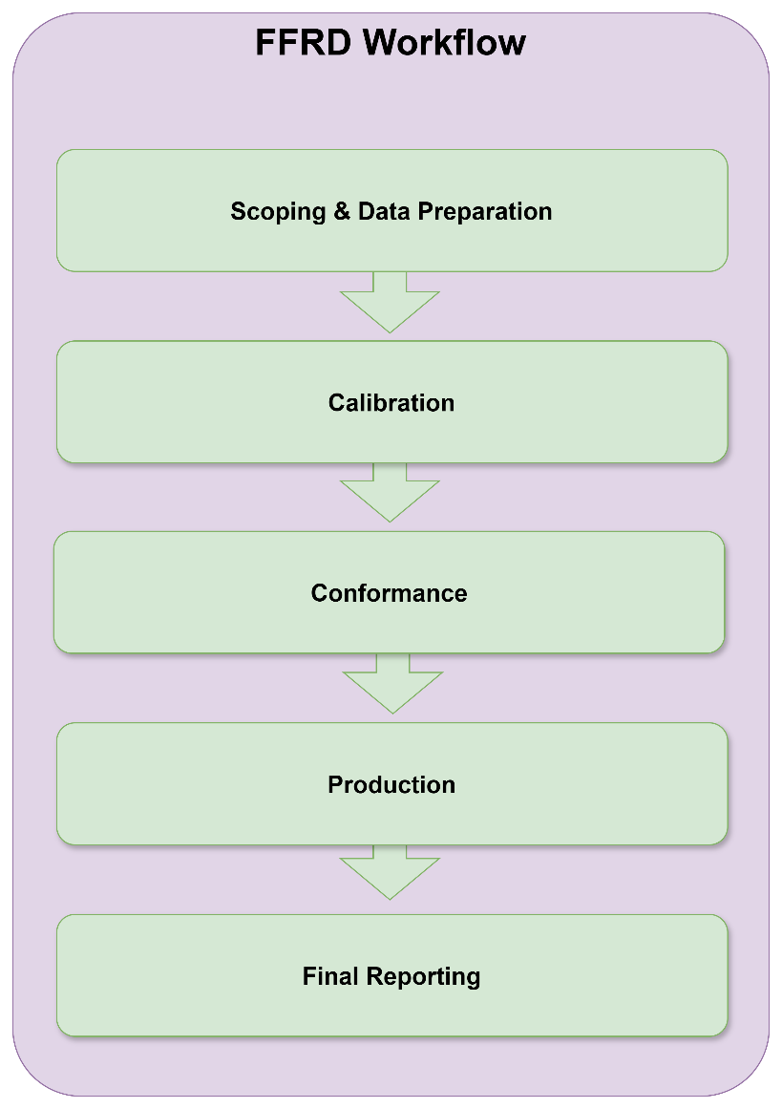

—Standards

Projection
[body text]
Table 2.1. Geospatial Projection Details
PROJCS | USA_Contiguous_Albers_Equal_Area_Conic_USGS_version
GEOGCS | GCS_North_American_1983
DATUM | D_North_American_1983
SPHEROID | GRS_1980, 6378137.0, 298.257222101
PRIMEM | Greenwich, 0.0
UNIT | Degree, 0.0174532925199433
PROJECTION | Albers
PARAMETER | False_Easting, 0.0
PARAMETER | False_Northing, 0.0
PARAMETER | Central_Meridian, -96.0
PARAMETER | Standard_Parallel_1, 29.5
PARAMETER | Standard_Parallel_2, 45.5
PARAMETER | Latitude_Of_Origin, 23.0
UNIT | Foot_US, 0.3048006096012192

Vertical Datum
Vertical Datum statement

Time Zone
Time zone statement

Access to All Prepared Data
Data delivered here is to be used as the authoritative dataset for the FFRD project.

Data Manifest
[body text]

Storage Location and Directory Structure
All datasets discussed in this report have been posted to the model library following the standard FFRD project directory structure in the repository named [repo name here].

Project Work Plan—Basin Execution
The draft basin execution project work plan (BE-PWP) is attached as an addendum to this report.

—Scoping

Watershed Study Extent
[body text]

External Boundary Conditions
Describe boundary conditions that are physically located outside of the modeling domain but have appreciable influence within the modeling domain that is currently being considered.

Model Order Design
[body text]

Enumeration of Cloud Simulations
[body text]

Naming Table
[body text]

Dam Scoping Table
[body text]

Levee Model Scoping Table
[body text]

Levee Draft Breach Locations
[body text]

Mesh Development Guidance
[repeat of guidance from SOP]

Mesh Development Categories
[body text]

Key Streams
[body text]

Other Streams
[body text]

Urban Areas
[body text]

Delineation of Hydrologic Modeling Basin Elements
[body text]

Delineation of Hydraulic Modeling Units
[body text]

Calibration Events
Describe the flood events that were selected for use during model calibration and how/why they were selected.

Calibration Metric Hierarchy
[body text]

Structure Survey Scope
[body text]

Stakeholder Engagment
Describe stakeholder engagement activities.

—Prepared Data

Geospatial Data
[body text]

Terrain
[body text]

Elevation Derived Hydrography
[body text]

Land Cover
[body text]

Soils
[body text]

National Levee Database
[body text]

National Inventory of Dams
[body text]

National Structure Inventory
[body text]

Bathymetry Data
[body text]

Stream Gage Network
[body text]

U.S. Census Bureau Topologically Integrated Geographic Encoding and Referencing Data
[body text]

National Bridge Inventory
[body text]

Observed Data
Describe QC and curation of observed datasets including adjustments for vertical datums, time zones, adjustments for missing data, filtering, etc.
[Annual maxima series (AMS) of basin average precipitation for each subbasin for period of record (POR) (from precipitation-only HMS run)—and evaluate for quality checks.]
Comparison of available gridded datasets (e.g., Analysis Of Record for Calibration [AORC] versus. Parameter-elevation Regressions on Independent Slopes Model [PRISM])

Observed Stream Gage Hydrographs
Elevation-storage, elevation-discharge, etc.

Stream Gage Measurement Data
All historic field data collected at stream gages

Stream Gage Annual Peak Data
[body text]

Stream Gage Stage Discharge Relationships (Ratings)
[body text]

High Water Mark Data
[body text]

Flood Imagery
[body text]

Period of Record Gridded Data
[body text]

Observed Storm Event Gridded Data
[body text]

Observed Precipitation
[body text]

Observed Snow Water Equivalent
[body text]

Observed Temperature Data
[body text]

Analysis Products
Analysis of observed data: such as frequency analysis, uncertain bounds computation

Meteorology
[body text]

Transposition Region
[body text]

Storm Catalog
[body text]

Theortical Maximum Return Period
[Report Tcap limitation based on ratio of Transposition Region Area to Study Basin Area and the period of record leveraged for storm catalog development]

Normalization Grid
[body text]

Fishnets
[body text]

Hydrologic Modeling
[describe the development and delivery of the uncalibrated base hydrologic model, which is consistent with certain other sections of this report]

Reference Data
[body text]

Dam Structure and Operation Information
[body text]

Vertical Datum Conversions
[body text]

Federal Emergency Management Agency Datasets
[body text]

Flood Insurance Study Effective Reports
[body text]

Flood Insurance Study Effective Models
[body text]

Flood Insurance Study Effective Layers
[body text]

Federal Emergency Management Agency Base Level Engineering Reports
[body text]

Federal Emergency Management Agency Base Level Engineering Models
[body text]

Federal Emergency Management Agency Base Level Engineering Data
[body text]

National Levee Database—Data Refinement
Describe completed process to improve and refine National Levee Database (NLD) data.

National Inventory of Dams—Data Refinement
Describe completed process to improve and refine National Inventory of Dams (NID) data.

Existing Risk Assessments
Describe risk assessment reports that have been collected to support development of system response curves (breach probability at dams and levees).

—Quality Control Reviews

Technical Reviews
[body text]

Quality Control
[body text]

This page is intentionally blank.

List of Acronyms and Abbreviations
AMS Annual maxima series
BE-PWP basin execution project work plan
BLE Base Level Engineering
FFRD Future of Flood Risk Data
NID National Inventory of Dams
NLD National Levee Database
POR period of record
QA quality assurance
QC quality control
SOP standard operating procedure
TIGER Topologically Integrated Geographic Encoding and Referencing
TOG Technical Oversight Group

